|  |  |
| --- | --- |
| logo | Year 7 Science  **Earth & Space 2 Test**  **SECTION 1: MULTIPLE CHOICE** (1 mark each)  Circle your answer on the multiple choice answer sheet. |

**Part 1 – Multiple choice**

1. Rocks are weathered to form materials that can then form part of a soil. Soils would therefore contain the following material that was originally part of the rock:
   1. Air
   2. Water
   3. Minerals
   4. Humus
2. The agents of erosion are:
   1. Water, air, wind and sunlight
   2. Ice, water, gases and rain
   3. Water, wind and rain
   4. Wind, water and ice
3. Soils are not renewable because they:
   1. can be eroded.
   2. are replaced too slowly.
   3. are formed from weathering of rocks.
   4. can be weathered.
4. Select the list of renewable energy sources from the alternatives below.
   1. Energy from coal, geothermal energy, tidal energy
   2. Wind energy, tidal energy, hydroelectric energy
   3. Solar energy, nuclear energy, wind energy
   4. Energy from coal, nuclear energy, wind energy
5. Select the alternative that cannot be used to produce biomass.
   1. Decomposing fruit peelings and grass clippings
   2. Human sewage and animal wastes
   3. Fermented sugarcane
   4. Recycled aluminium

*For Question 6 and 7 use the diagram to answer the questions*

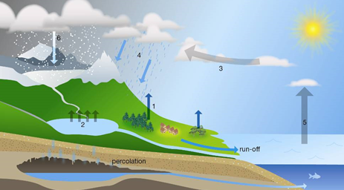

1. Sate the process occurring at position 2.
   1. Precipitation
   2. Evaporation
   3. Condensation
   4. Transpiration
2. State the process that has occurred at position 1.
   1. Precipitation
   2. Evaporation
   3. Condensation
   4. Transpiration
3. State the largest source of evaporation in the water cycle.
   1. The oceans, because they are the largest bodies of water
   2. Vegetation, because the leaves of trees and other plants have such a large surface area
   3. Turbulent rivers and streams and waterfalls where there is a lot of spray going into the air
   4. Spray irrigation of large agricultural areas
4. Human activities have upset the natural water cycle in many places. Select the human activity that is an attempt to restore an aspect of the natural water cycle.
   1. Irrigation of crops
   2. Replacing forest with food crops
   3. Building of dams
   4. Construction of rain gardens

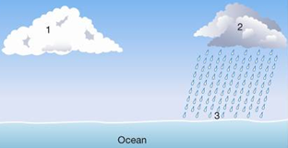

1. Using the information provided in the diagram, identify which of the following statements is *untrue*.
   1. The air at 1 is saturated.
   2. Evaporation is taking place at 3.
   3. Run-off will occur when the precipitation reaches 3
   4. The water droplets at 1 are smaller than at 2.

**Part 2 - Short Answers**

1. a. Define what is meant by a renewable resource. (2 marks)

b. Explain why rocks and soils are not renewable resources, but living things are renewable. (2 marks)

1. a. Name two processes that return gases to the air. (2 marks)

b Describe a process in animals that affects oxygen and carbon dioxide levels in the air. (2 marks)

3. Hannah and Omar used the following equipment to study how plants affect the air.

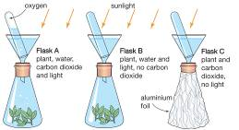

* 1. Explain what would have happened in flask A. (2 marks)
  2. Explain why flask B would have a different result from flask A. (1 mark)

4. Explain the difference between a renewable and a non-renewable energy source. Give an example of each type. (2 marks)

5. Diagram below shows a soil profile

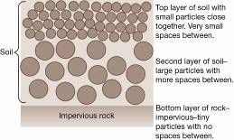

a. Describe what could happen to water falling on the surface of the soil.

(2 marks)

b Compare what would happen to the water if there was extremely heavy rainfall rather than a steady shower of rain. (2 marks)

6. Draw a graph showing the 6 major sources of CO2

Table 1: Estimated CO2 Sources in 2012

|  |  |
| --- | --- |
| Source | Gigatons per year |
| Coal combustion | 15.8 |
| Oil combustion | 12.1 |
| Gas combustion | 6.6 |
| Cement manufacture | 1.9 |
| Gas flaring | 0.2 |
| Land use | 3.6 |

